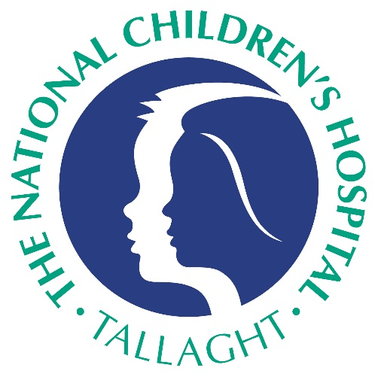

2018 National Children’s Hospital Foundation Research Grant Round now open

Through the generosity of our supporters, the NCH Foundation funds research that has a strong focus on translational outcomes, improves children’s health and leads to faster diagnoses, better treatments and ultimately cures for illnesses that affect children, as patents of the hospital here at Tallaght.

Call for applications for the first round of funding is now open.

Applications are welcome from current staff - clinicians, nursing and healthcare professionals who wish to undertake a research project of relevance to paediatric healthcare at the hospital.
Grants will be approved on a yearly basis for projects up to a maximum of three years. The maximum funding available for each successful project is €50k per year (€150k for three years).

All applications made over the amount of €25,000 will be subject to an external peer review process.

For more information, copy of guidelines and application form regarding research grants please contact Laura Gallagher at the Foundation office on 01 4142373 or laura.gallagher2@amnch.ie

Closing date for receipt of applications is Thursday, March 1st 2018

